Anytown Station Ground Risk Analysis

Overview

We have looked at all the households in Oxfordshire and categorised them into risk categories using information such as property type, household composition, socio-economic standing and demographic data to figure out where our resources are best placed.

We need crews to go out into the community and engage with residents in these high-risk areas: offering advice, creating fire safety awareness and offering safe and well visits. Targeting these areas, it is hoped that we can gain access to vulnerable residents and their homes proactively, in order to reduce the likelihood of severe fires around the county.

The green circles correspond to all the Risk Rank 1 incidents across Oxfordshire. These are households where we believe a fire is highly likely to occur and where the severity of that fire is also high – making these households extremely at risk of loss of life.

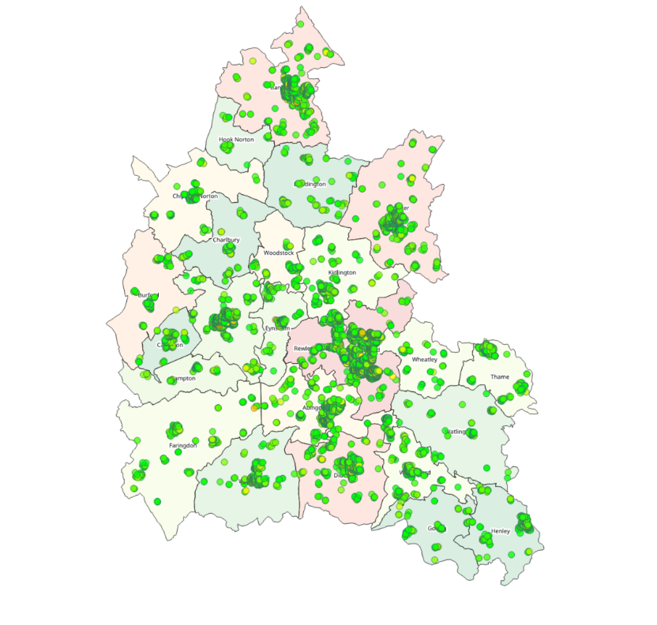
Ranking System

297460 total households divided into 10 ranks

Rank 1

Likelihood (HIGH) X Severity (HIGH)

Rank 5

Likelihood (MED) X Severity (MED)

Rank 10

Likelihood (LOW) X Severity (LOW)

A total of 1795 households in Anytown have a risk rank of 1 in the (Highest priority = Black dots). We may be able to go to all of these houses individually for a safe and well visit, but this may take a long time.

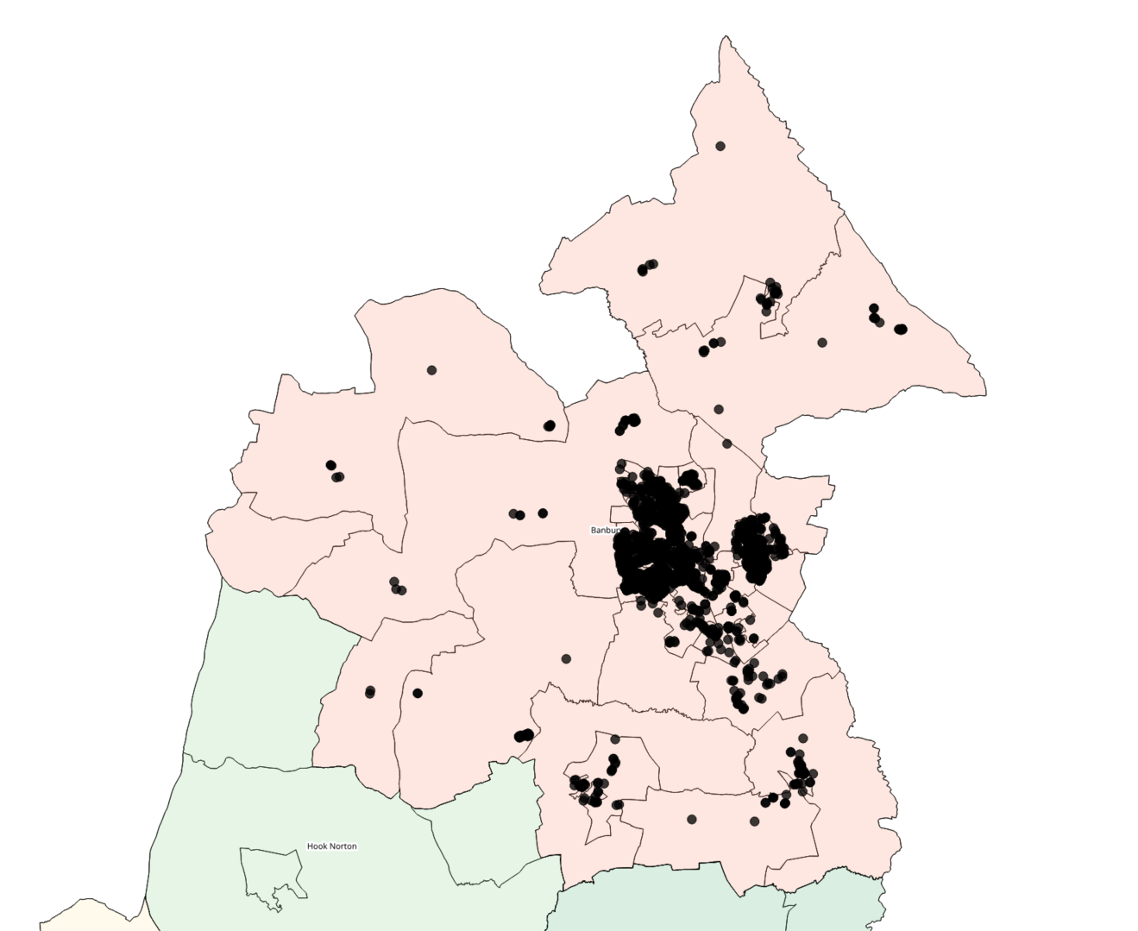

In the interim, we can target certain high-density areas, to make awareness to the public and offer safe and well visits to the highly vulnerable. These vulnerable residents will be those black dots who lie near areas where we have previously recorded fires.

There are 728 households in this position, with most of the schools in Anytown in these areas, as well as being the epicentre for residential dwellings and business.

By targeting the areas that have the highest concentration of vulnerable households, we can quickly arrange for engagement within the community. If residents engage with crews and advise on households they know of where fire safety is a concern (elderly parents etc.), we can record these locations and arrange safe and well visits.

Priority engagement areas

Area 1 – Somewhere Hill

The Somewhere Hill area is to the west of Anytown CC. This area has the most vulnerable households in this ranking with 202 households. Crews need to go out into the yellow areas and engage with residents.
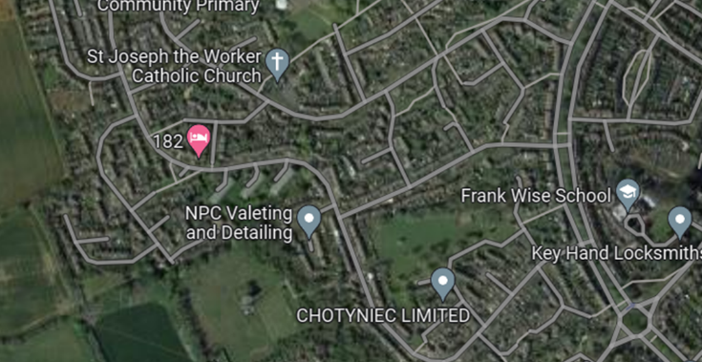
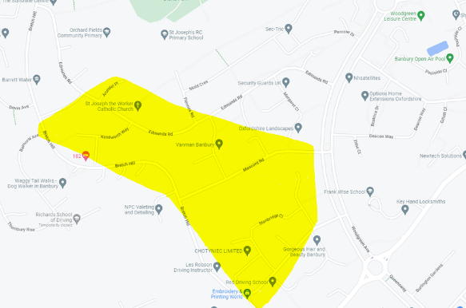

Somewhere Hill Stats

- 27% Residents aged 56-60, 15% 46-50
- 69% Terraced, %25 semi-detached
- Average income of 18-23k
- Mostly single elderly females and families
- 50% of households have children present
- 77% of Households are council/association housing

Somewhere Hill Recommendations

- Multiple schools (St. Joseph's, Orchard Fields, Frank Wise)in close proximity: Opportunities here to engage with and gain allyship from schools. Awareness to be brought back home from school flyers etc).
- St Joseph the Worker church is in close proximity. Engaging with long standing community institutions could be beneficial to community engagement.
- Princess Diana Park: opportunities here to erect marquis and tents for community engagement.

Area 2 – Happy Acres

The 2nd largest is location, with 191 households in close proximity is the Happy Acres area, just off Foxhall Road and Station Road. Crews should go out into the yellow area for engagement.
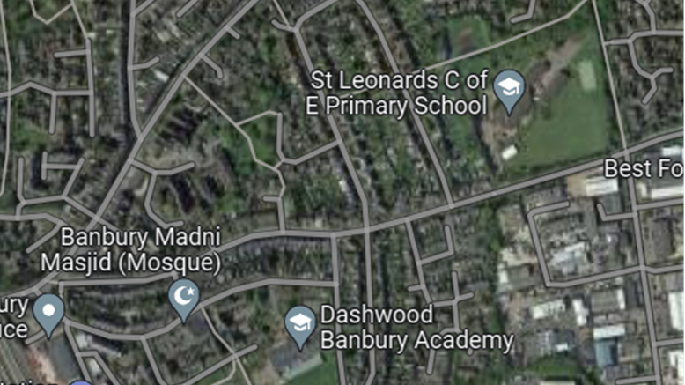
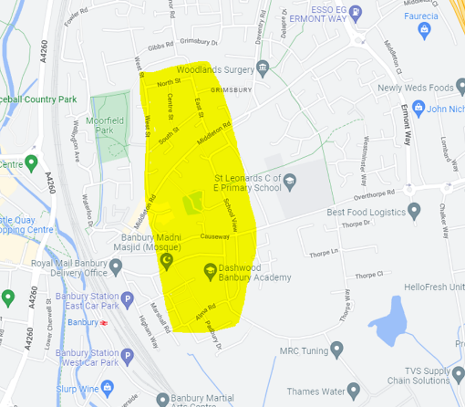

Happy Acres Stats

- 3 main age groups:
  - 46-60
  - 76+
  - 36-40
- 71% Terraced, 15% self-contained flats, 13% semi-detached
- 33% Average income of <15k, 29% Average income of 20-29k,
- Mostly elderly singles and Families
- 40% of households with children
- 62% of households are council/association.

Happy Acres Recommendations

- Anytown Madni Masjid Mosque is in close proximity. Engaging with members of different communities could lead to on-going partnerships with FRS, and a sense of togetherness.
- St Leonard's, Dashwood Academy: Opportunities here to engage with and gain allyship from schools. Awareness to be brought back home from schools here again, (flyers etc).
- Moorfield Park: opportunities here to erect marquis and tents for community engagement.

Safe and Well Team and Community Engagement

The Safe and Well Team can provide support for events if requested, but the overall responsibility for carrying out engagement activities will fall to your station.

They can also provide support for more complex cases, such as severe hoarding or special requests for equipment.

Please note.
The information within this document is out of date and some details have been changed. It is being used to provide background information for this case study process only.

