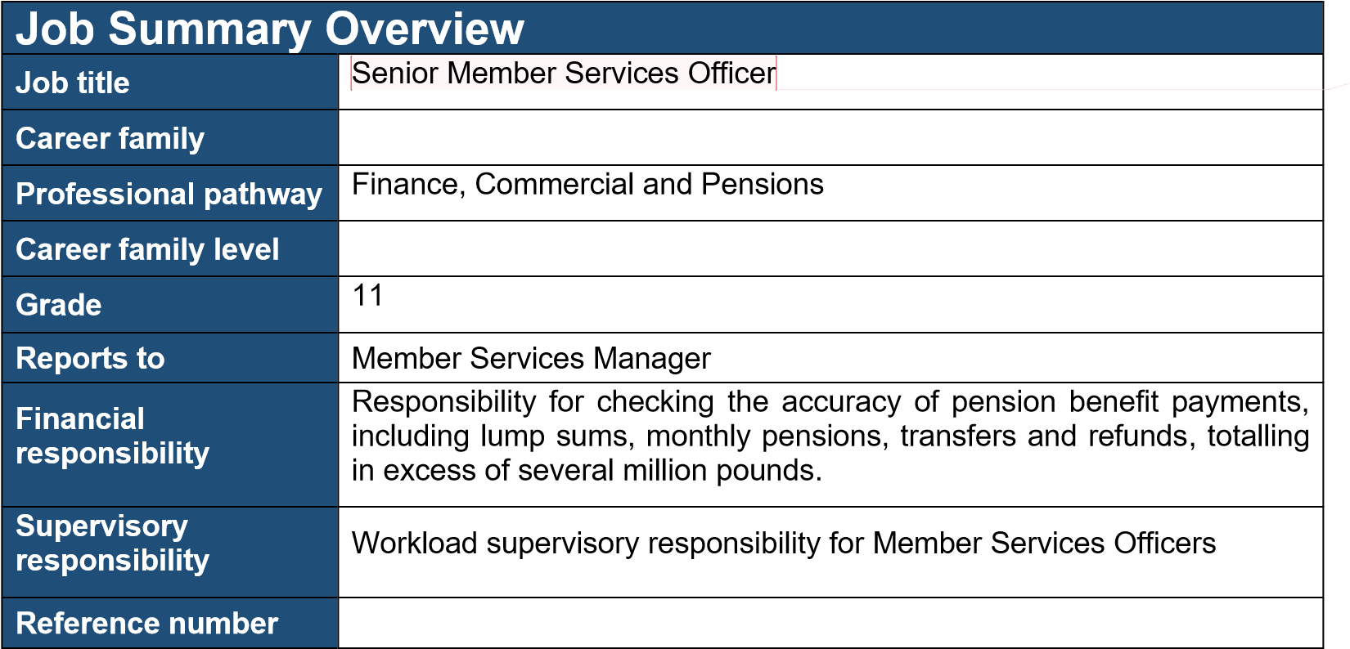
Job Summary
The Senior Member Services Officer is a specialist within the Member Services Team of
Oxfordshire Pension Fund, ensuring accurate and timely administration of the Local Government Pension Scheme (LGPS) in line with statutory regulations, relevant guidance and Fund policies.

The post holder provides technical guidance, quality assurance and mentoring to Officers within the team, leads on complex casework and bulk processing activities, and works closely with scheme employers and scheme members to maintain high standards of data quality, customer service and regulatory compliance.

Key Responsibilities and Deliverables

- Act as a senior specialist for the LGPS interpreting and applying complex regulations, guidance and Fund policies to a wide range of cases.
- Lead on complex and sensitive casework (e.g. ill-health, death benefits, divorce benefits, transfers in and out), performing and checking automated benefit calculations and, where necessary, manual calculations.
- Provide day-to-day technical support, coaching, mentoring and supervising Pensions Officers within the team, checking and authorising complex processes and calculations, including cases which result in significant monthly pensions and lump-sum payments being put into payment, and giving constructive feedback to improve quality and consistency of work.
- Use system workflow and reporting tools to manage own caseload, support the Member Services Managers in monitoring work in progress, manage fluctuating volumes of casework, and take ownership in supporting the team to meet statutory requirements and key performance indicators.
1
• | Independently liaise with scheme employers and third-party payroll providers to obtain and validate complex data, resolve queries and ensure the accuracy and completeness of information and data.
• | Process complex pensions benefit payments and apply quality assurance checks for other colleagues processed cases, investigating and resolving payment issues to safeguard the financial integrity of the Fund and protect members from financial loss arising from error.
• | Provide clear, accurate and timely information to scheme members, beneficiaries, employers and other stakeholders, explaining complex pension options and implications using clear and accessible language.
• | Handle contentious, emotional and sensitive enquiries (such as bereavement or serious ill-health) with empathy and professionalism, and in line with Fund policies.
• | Contribute to the design, testing and implementation of new or revised procedures, system changes and guidance notes, providing expert operational input and proactively identifying opportunities to improve efficiency and customer experience and sharing these with the Team Leaders.
• | Where required, participate in and deliver presentations, briefings and training sessions for members, employers and colleagues on pension scheme changes and their implications
• | Work in accordance with pensions legislation, Fund policies, internal controls and audit requirements, maintaining accurate records and audit trails.
• | Undertake any other duties consistent with the purpose and level of the role, as agreed with the Member Services Managers as required.

Specific requirements |  | Essential  Mark with  | Desirable  Mark with 
Educated to A-level (or equivalent) with GCSE passes in English and Maths, or with equivalent experience in an administration or pensions role. |  |   |  
Relevant pension administration qualification (e.g. PMI/IPPM/CIPP or equivalent). |  |  |  
Experience of working in an LGPS fund or similar pensions environment, with knowledge and understanding of the regulatory provisions of the scheme and other related legislation. |  |   |  
Experience of using pensions administration systems (e.g. Altair) to process and check member records and benefits. |  |   |  
Ability to build and maintain effective working relationships with a wide range of stakeholders, including members, employers and colleagues. |  |   |  
Excellent customer service skills, with the ability to explain complex pensions information clearly and professionally by telephone, in writing, by email and in person. |  |   |  
Strong numeracy, literacy and analytical skills, with a high level of attention to detail and the ability to ensure accuracy when reviewing complex calculations and quality-checking the work of others where required. |  |   |  
Proven problem-solving skills, with the ability to deal with complex cases, interpret regulations and guidance, and apply sound, evidence-based judgement. |  |   |  
 | 2
Customer-focused, reliable and flexible, with a strong commitment to accuracy, service quality and continuous improvement, and a proactive approach to improving service delivery. |  |   |  
Good organisational skills and the ability to prioritise own workload across competing deadlines, working with minimal day-to-day supervision. |  |   |  
Ability to build and maintain effective working relationships and to work collaboratively with colleagues, contributing to team performance goals and supporting a consistent, high-quality service. |  |   |  
Clear understanding of the need for confidentiality and care when handling personal and financial data, ensuring compliance with data protection requirements and secure access controls. |  |   |  
Committed to equality, diversity and inclusion and to demonstrating the values and codes of conduct of the administering authority. |  |   |  

Working Arrangements
- The post is not politically restricted.
- Contractual base as detailed on contract, but you are able to work on a flexible basis in line with our Agile Working Policy
- Able to travel across the county and work from various office locations within the county.

Health and Safety at Work
All employees have responsibilities for health and safety – both for themselves, colleagues and the people we work with.

The potential significant hazard(s) and risk(s) for this post are identified below (those ticked).

☐ | Provision of personal care on a regular basis | ☐ | Driving HGV or LGV for work
☐ | Regular manual handling (which includes assisting, manoeuvring, pushing and pulling) of people (including pupils) or objects | ☐ | Any other frequent driving or prolonged driving at work activities (e.g. long journeys driving own private vehicle or a council vehicle for work purposes)
☐ | Working at height/ using ladders on a regular/ repetitive basis | ☒ | Restricted postural change – prolonged sitting
☐ | Lone working on a regular basis | ☐ | Restricted postural change – prolonged standing
☐ | Night work | ☐ | Regular/repetitive bending/ squatting/ kneeling/crouching
☐ | Rotating shift work | ☐ | Manual cleaning/ domestic duties
☐ | Working on/ or near a road | ☐ | Regular work outdoors
☒ | Significant use of computers (display screen equipment) | ☐ | Work with vulnerable children or vulnerable adults
☐ | Undertaking repetitive tasks | ☐ | Working with challenging behaviours
☐ | Continual telephone use (call centres) | ☐ | Regular work with skin irritants/ allergens
3

☐ | Work requiring hearing protection (exposure to noise above action levels) | ☐ | Regular work with respiratory irritants/ allergens (exposure to dust, fumes, chemicals, fibres)
☐ | Work requiring respirators or masks | ☐ | Work with vibrating tools/ machinery
☐ | Work involving food handling | ☐ | Work with waste, refuse
☐ | Potential exposure to blood or bodily fluids | ☐ | Face-to-face contact with members of the public
☐ | Other (please specify):

