Job Description

Section A: Job Profile
The job profile outlines key information relating to the salary and working conditions e.g., location of a job, along with the current focus of the role and a brief description of the main duties.

Job Details
Job Title: | Climate Officer
Salary: | £30,559 - £33,366
Grade: | 8
Hours: | 22.2 per week. We are open to discussions about flexible working.
Team: | Zero Carbon Oxfordshire
Service Area: | Climate Action
Primary Location: | County Hall, Oxford OX1 1ND.  This role can be delivered with a blend of home working  Please note we are actively looking at our ways of working using everything we have learnt and heard from our people about the organisational and personal benefits of agile working. What you can absolutely expect from working at Oxfordshire County Council (OCC) is that you will have the support to do your job and deliver great results, wherever you are based. Each role at OCC is different and we know the needs of individuals are also varied, and so our approach to where and how often we would like to see you in person will be taken depending on the requirements of the role and in collaboration with you as part of the recruitment process.
Budget responsibility: | None
Responsible to: | Climate Policy and Partnership Manager
Responsible for: | Not applicable
Political Restricted Post: | Not a restricted post

Job Purpose
The post holder will provide a key supporting role to senior officers across the Climate Action service. The role will be able to assist the Zero Carbon Oxfordshire Team in the preparation of climate action policy, research and project delivery. The post will involve evidence gathering, data collation, monitoring and analysis to enable the successful delivery of the council’s climate objectives.

To support our Organisation, People and Partners to look forward, using analysis and evidence to inform plans, manage risks appropriately and apply insight to ensure the delivery of effective services for our local people.

To learn and adapt to deliver positive outcomes in efficient and consistent ways, constructively challenging how services are provided and working together to build on our strengths.

The role will require working with Senior Officers, Officers, Members, Suppliers, Communities and other Partners, therefore being able to build working relationships and effectively communicate professional advice is vital.

Job Responsibilities
Technical / Professional Skills

The role will be focused on climate policy and strategy activity and providing support to the other parts of the Climate Action service as required. This will include assisting with climate policy, research and project work:

- Working throughout the Climate action service, across the Council and with partners relevant to the Zero Carbon Oxfordshire route map and Climate Adaptation route map to support strategic projects, as identified with the Climate Policy and Partnership Manager;
- Evidence gathering for the biannual reports to Cabinet and policy work;
- Community engagement such as consultations, followed by supporting the collation of representations from public consultation and helping to prepare summary documents;
- Delivering research into best practice on climate mitigation, climate adaptation and outreach/engagement to inform the work of the Zero Carbon Oxfordshire team. Digital mapping and web-based systems;
- Delivering the Secretariat function for the Council’s Climate Action Programme Board, ensuring smooth running of meetings including scheduling, coordinating agendas and action logs and minute taking.
- Liaising with other Teams across the Authority, Members, Industry and members of the Public as required
- Collating internal and external comments on relevant government consultations
- Gathering information and drafting quarterly updates for corporate performance monitoring of climate KPIs
- Ensuring team documentation is well organised and accessible to all on Teams and SharePoint
- Assisting in responding to FOI and EIA requests
- Preparation of plans and presentations for Climate Board and other meetings of the council

Relationships and Stakeholder Management
- To build and promote relationships across the Council, its Suppliers and other Partners while delivering effective and consistent services, which represent value for money.
- Engage with staff and stakeholders to shape and agree priorities and objectives in line with the service plan and relevant corporate policies and external legislation.
- To contribute to the development of advice, written reports and briefings relating to climate activity to Members, both Council’s Leadership Team, Programme Boards, Committees and other stakeholders as required.

Any other duties as may be deemed necessary to carry out the full remit of the role.

Our Values
Our organisational values underpin everything we do and say and are supported by policies, processes and guidance. In short, our values describe ‘the way we do things here’ so that we deliver great services for our residents. Our values are:
- Always learning
- Be kind and care
- Equality and integrity in all we do
- Taking responsibility
- Daring to do it differently
Everyone that works for us demonstrates their commitment to these values. We will ask you to demonstrate your commitment to these values, and their associated behaviours, throughout the application process.

Section B: Selection Criteria/Person Specification
This section provides a list of essential and desirable criteria that detail the skills, knowledge, behaviours, qualifications and experience that a candidate should have to perform the job.

Each of the criteria listed below, and your commitment to our values, will be measured through the application form/CV (A) and optionally one or more of the following - a test / exercise (T), an interview (I), a presentation (P) or documentation (D). You must provide a supporting statement as part of your application which includes examples and evidence of when you have demonstrated the criteria listed below.

Essential Criteria | Assessed By:
Undergraduate Degree in a relevant subject or equivalent experience | A / I
Evidence of using own judgment in a range of situations | A / I
Excellent communication, presentation and negotiation skills, to prepare clear and concise reports | A / I
Understanding and experience using data, insight and performance measures to assess the impact of services and inform decisions and service planning to improve outcomes. | A / I
Knowledge of programme and project management, including managing complex multi-partner projects | A / I
Experience of managing collaboration partnerships | A / I
Ability to work efficiently both independently and as part of a team both inside and away from the office. | A / I
Proficient in MS Office skills (Word, Outlook, Excel etc.) | I
Desirable Criteria | Assessed By:
Knowledge and experience of climate policy | A / I
Knowledge of GIS | A / I

Section C: Pre-employment Checks
All appointments are subject to standard pre-employment screening. This will include identity, references, proof of right to work in the UK, medical clearance and verification of certificates. Further information can be found here Pre-employment checks

Additional pre employment checks specific to this role are identified below (those ticked).

☐ | Enhanced Disclosure and Barring Service check with Children’s and Adults Barred List | ☐ | Enhanced Disclosure and Barring Service check without an Adult/Children’s barred list check
☐ | Enhanced Disclosure and Barring Service check with Children’s Barred List | ☐ | Enhanced Disclosure and Barring Service check with Adults Barred List
☐ | Standard Disclosure and Barring Service check | ☐ | Basic Disclosure
☐ | Disqualification for Caring for Children (Education) | ☐ | Overseas Criminal Record Checks
☐ | Prohibition from Teaching | ☐ | Professional Registration
☐ | Non police personnel vetting | ☐ | Disqualification from Caring
☐ | Other (please specify):

Section D: Working Conditions
This is a guide to the working conditions and the potential hazards and risks that may be faced by the post-holder.

Health and Safety at Work

You are responsible for your own health, safety and wellbeing, and undertaking health and safety duties and responsibilities for your role as specified within Oxfordshire County Councils Health and Safety Policy.

The potential significant hazard(s) and risk(s) for this job are identified below (those ticked).

☐ | Provision of personal care on a regular basis | ☐ | Driving HGV or LGV for work
☐ | Regular manual handling (which includes assisting, manoeuvring, pushing and pulling) of people (including pupils) or objects | ☐ | Any other frequent driving or prolonged driving at work activities (e.g. long journeys driving own private vehicle or a council vehicle for work purposes)
☐ | Working at height/ using ladders on a regular/ repetitive basis | R | Restricted postural change – prolonged sitting
☐ | Lone working on a regular basis | ☐ | Restricted postural change – prolonged standing
☐ | Night work | ☐ | Regular/repetitive bending/ squatting/ kneeling/crouching
☐ | Rotating shift work | ☐ | Manual cleaning/ domestic duties
☐ | Working on/ or near a road | ☐ | Regular work outdoors
R | Significant use of computers (display screen equipment) | ☐ | Work with vulnerable children or vulnerable adults
☐ | Undertaking repetitive tasks | ☐ | Working with challenging behaviours
☐ | Continual telephone use (call centres) | ☐ | Regular work with skin irritants/ allergens
☐ | Work requiring hearing protection (exposure to noise above action levels) | ☐ | Regular work with respiratory irritants/ allergens (exposure to dust, fumes, chemicals, fibres)
☐ | Work requiring respirators or masks | ☐ | Work with vibrating tools/ machinery
☐ | Work involving food handling | ☐ | Work with waste, refuse
☐ | Potential exposure to blood or bodily fluids | R | Face-to-face contact with members of the public
☐ | Other (please specify):

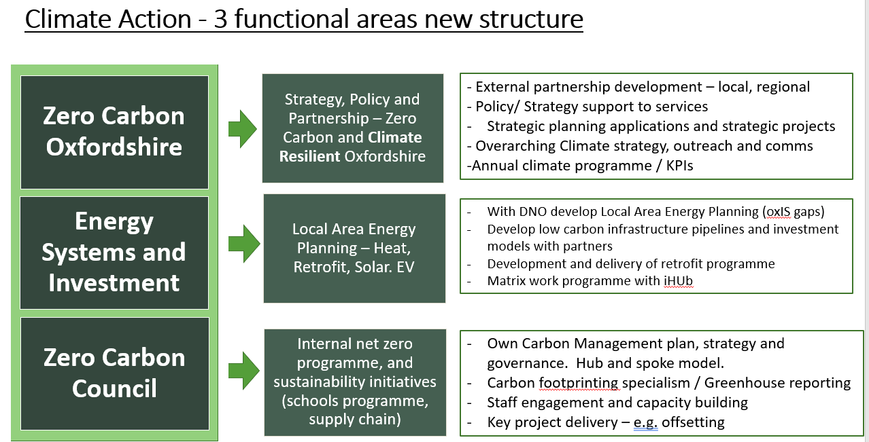
August 2025

