Job Description

Section A: Job Profile
The job profile outlines key information relating to the salary and working conditions e.g., location of a job, along with the current focus of the role and a brief description of the main duties.

Job Details
Job Title: | Technical Lead – Planning and Climate
Salary: | £43,421 - £46,464
Grade: | 12 (Technical Lead)
Hours: | 21 per week. We are open to discussions about flexible working.
Team: | Zero Carbon Oxfordshire
Service Area: | Climate Action
Primary Location: | County Hall, Oxford OX1 1ND.  This role can be delivered with a blend of home working.  Please note we are actively looking at our ways of working using everything we have learnt and heard from our people about the organisational and personal benefits of agile working. What you can absolutely expect from working at Oxfordshire County Council (OCC) is that you will have the support to do your job and deliver great results, wherever you are based. Each role at OCC is different and we know the needs of individuals are also varied, and so our approach to where and how often we would like to see you in person will be taken depending on the requirements of the role and in collaboration with you as part of the recruitment process.
Budget responsibility: | None
Responsible to: | Zero Carbon Oxfordshire Partnership and Programme Manager
Responsible for: | None
Political Restricted Post: | Not a restricted post

Job Purpose
Oxfordshire County Council has put Climate Action at the heart of its corporate agenda. In a County where our partners and communities are passionate about addressing the climate emergency, home to world leading climate research, and a thriving innovation economy, we believe Oxfordshire will be at the forefront of the zero-carbon transition.
The Climate service is made up of three teams (see below). This post sits within the first of these:
- Zero Carbon Oxfordshire team
- Energy Systems and Investment team
- Zero Carbon Council team
The purpose of this job is to ensure the council develops best practice policy to meet its climate commitments through the planning system, as consultee, developer and local planning authority.

The role will be the technical expert within the Council in relation to using County Council Planning powers and influence to meet climate objectives.

The post holder will deputise for the Partnership and Programme Manager – Zero Carbon Oxfordshire if required.

The post holder will be accountable for the following activities:-

- Working within the Climate action wider service and across the organisation, particularly Environment and Place, to support the inclusion of specialist climate action policy into relevant work areas. Specifically taking a strategic approach to, and operational engagement with, our net zero and climate adaptation objectives, within the context of the Council’s statutory role as planning authority and where appropriate as a landowner and scheme developer.
- Providing significant technical advice to colleagues in relation to the preparation, adoption and implementation of Local Plans (including Supplementary Planning Documents, Area Action Plans, Garden Town / Village proposals, and planning applications for Strategic Sites), Neighbourhood Plans and input into strategic infrastructure development proposals.
- Develop systems to ensure the organisation stays up to date with national policy changes and develops strong response to appropriate consultations.
- Supporting and enabling colleagues across Environment and Place including providing specialist advice, training and support to colleagues.
- Working with colleagues to identify and evaluate the opportunities for income generation aimed at improving services and delivering new revenue streams particularly but not exclusively through Planning Performance Agreements
- The role will require working with members of the Future Oxfordshire Partnership, Environment Advisory Group, Senior Leadership Team, other Senior Officers, Members, Suppliers, Communities and other Partners, therefore being able to build working relationships and effectively communicate complex, professional advice is vital.

Job Responsibilities
Technical / Professional Skills
- Providing significant technical advice to colleagues in relation to practical, best practice solutions on Climate and Planning by:
  - Assessing and responding to planning applications for which the council is the determining authority, including minerals and waste, Reg 3 and transport schemes.
  - Supporting County Council representations on climate issues at legal and public inquiries and other planning related reviews and meetings.
  - Liaising with other County Council staff and providing assistance to developers as part of the County Council’s input to pre-application discussions on strategic development proposals as required, including through the use of Planning Performance Agreements
  - Providing advice to the council’s development funding team to secure and spend developer contributions for climate mitigation and adaptation.
  - Providing advice to the council’s planning enforcement team to monitor and enforce planning conditions and legal agreements for net zero and climate adaptation.
  - Engaging with internal and external stakeholders, including district and city council climate specialists and other local organisations dealing with climate issues.
  - Providing the county council’s responses to Neighbourhood Plans in relation to climate considerations and liaise with Parish and District Councils as appropriate.
  - Supporting work on Oxfordshire’s strategic development sites to ensure the county council’s climate objectives are taken on board and applied as appropriate. This includes communicating (written and verbal) with a varied group of stakeholders (Councillors, Developers, Consultants, District Councils as well as internal colleagues)
  - Developing specialised locality specific knowledge to ensure that consistent, accurate and relevant advice is being provided to that area.
- Engaging and developing the Climate Action Programme Board, made up of senior leaders across the Council.
- Working with national and regional officer groups (including OxCam Regional Partnership) to ensure the council benefits from, and shares best practice on, climate and planning policy including coordinating meetings of a group of climate officers across Oxfordshire
- Proactively lead, improve and deliver tracking and reporting the council’s climate action programme, recognising these are high profile and sometimes politically sensitive complex projects and programmes.
- Produce high quality project documentation establishing project objectives and benefits, metrics, risk, and financial data in addition to cost / benefit analysis to prioritise scope / phasing of deliverables with associated production of detailed project plans and an assurance framework.
- To support our Organisation, People and Partners to look forward, using analysis and evidence of future technologies, and best practice to inform plans, manage risks appropriately and apply insight to ensure the delivery of effective services for our local people.
- The role will require working with members of the Senior Leadership Team, other Senior Officers, Members, Suppliers, Communities and other Partners, therefore being able to build working relationships and effectively communicate complex, professional advice is vital.

Technical/Knowledge Leadership
- To act as the centre point of technical expertise on Climate and Planning within the council.
- To select and manage external planning consultants with climate expertise as required.
- To monitor and update the team on relation changes needed to policy and best practice
- Raise the profile of the Council in relation to its proactive role in using planning to achieve climate objectives by attending local and national forums and promoting the work of the Council across a range of media.
- Reviewing and providing quality assurance into the technical work of colleagues
- Embed a culture of continuous improvement, building skills and knowledge amongst staff across the climate action functional area.

Relationships and Stakeholder Management
- To build and promote relationships across the Council, its Suppliers and other Partners to ensure the council plays a supportive, convening role on climate policy.
- Engage with staff and stakeholders to shape and agree priorities and objectives in line with the service plan and relevant corporate policies and external legislation.
- To contribute to the development of advice, written reports and briefings and lunch and learns relating to climate resilience activity to Members, both Council’s Leadership Team, Programme Boards, Committees, MPs, and other stakeholders as required.

Any other duties as may be deemed necessary to carry out the full remit of the role.

Our Values
Our organisational values underpin everything we do and say and are supported by policies, processes and guidance. In short, our values describe ‘the way we do things here’ so that we deliver great services for our residents. Our values are:
- Always learning
- Be kind and care
- Equality and integrity in all we do
- Taking responsibility
- Daring to do it differently
Everyone that works for us demonstrates their commitment to these values. We will ask you to demonstrate your commitment to these values, and their associated behaviours, throughout the application process.

Section B: Selection Criteria/Person Specification
This section provides a list of essential and desirable criteria that detail the skills, knowledge, behaviours, qualifications and experience that a candidate should have to perform the job.

Each of the criteria listed below, and your commitment to our values, will be measured through the application form/CV (A) and optionally one or more of the following - a test / exercise (T), an interview (I), a presentation (P) or documentation (D). You must provide a supporting statement as part of your application which includes examples and evidence of when you have demonstrated the criteria listed below.

Essential Criteria | Assessed By:
Degree level qualification in planning or relevant subject or equivalent experience. | A
Significant experience working in a planning role | A,D
Expert knowledge developing climate mitigation policy particularly, but not exclusively, in the planning system, built environment and transport | A/I
Demonstrable commitment to continuing professional development related to the role such as membership to a professional body eg, RTPI | A / I
Expert knowledge of national planning policy and legislation and the funding context for net zero and climate mitigation. | A/I
Experience of developing strategies to drive change, including in partnership, requiring project management skills and effective communication of key messages to diverse teams. | A / I
Ability to use own judgment in a range of situations, dealing with councillors and officers within and outside the organisation. | A / I
Excellent communication, presentation and negotiation skills, to prepare clear and concise reports | A / I
Understanding and experience using data, insight and performance measures to assess the impact of services and inform decisions and service planning to improve outcomes. | A / I
Demonstrable experience of effective engagement with customers and stakeholders within a public service context. | A
Strong partnership work ethic with a proven track record of embracing and maintaining successful partnerships with a wide range of internal and external stakeholders. | A / I
Proficient in MS Office skills (Word, Outlook, Excel etc.) | I
Desirable Criteria | Assessed By:
Understanding the need to comply with the Council’s constitution, including its contract and financial procedures and regulations | A/I
Previous experience of working at a similar level in Local Government | A/I
A working knowledge of financial and budgetary management | A,I
A broad knowledge of commissioning and procurement arrangements to enable project management of service led procurements and new service implementation | A,I

Section C: Pre-employment Checks
All appointments are subject to standard pre-employment screening. This will include identity, references, proof of right to work in the UK, medical clearance and verification of certificates. Further information can be found here Pre-employment checks

Additional pre employment checks specific to this role are identified below (those ticked).

☐ | Enhanced Disclosure and Barring Service check with Children’s and Adults Barred List | ☐ | Enhanced Disclosure and Barring Service check without an Adult/Children’s barred list check
☐ | Enhanced Disclosure and Barring Service check with Children’s Barred List | ☐ | Enhanced Disclosure and Barring Service check with Adults Barred List
☐ | Standard Disclosure and Barring Service check | ☐ | Basic Disclosure
☐ | Disqualification for Caring for Children (Education) | ☐ | Overseas Criminal Record Checks
☐ | Prohibition from Teaching | ☐ | Professional Registration
☐ | Non police personnel vetting | ☐ | Disqualification from Caring
☐ | Other (please specify):

Section D: Working Conditions
This is a guide to the working conditions and the potential hazards and risks that may be faced by the post-holder.

Health and Safety at Work

You are responsible for your own health, safety and wellbeing, and undertaking health and safety duties and responsibilities for your role as specified within Oxfordshire County Councils Health and Safety Policy.

The potential significant hazard(s) and risk(s) for this job are identified below (those ticked).

☐ | Provision of personal care on a regular basis | ☐ | Driving HGV or LGV for work
☐ | Regular manual handling (which includes assisting, manoeuvring, pushing and pulling) of people (including pupils) or objects | ☐ | Any other frequent driving or prolonged driving at work activities (e.g. long journeys driving own private vehicle or a council vehicle for work purposes)
☐ | Working at height/ using ladders on a regular/ repetitive basis | R | Restricted postural change – prolonged sitting
☐ | Lone working on a regular basis | ☐ | Restricted postural change – prolonged standing
☐ | Night work | ☐ | Regular/repetitive bending/ squatting/ kneeling/crouching
☐ | Rotating shift work | ☐ | Manual cleaning/ domestic duties
☐ | Working on/ or near a road | ☐ | Regular work outdoors
R | Significant use of computers (display screen equipment) | ☐ | Work with vulnerable children or vulnerable adults
☐ | Undertaking repetitive tasks | ☐ | Working with challenging behaviours
☐ | Continual telephone use (call centres) | ☐ | Regular work with skin irritants/ allergens
☐ | Work requiring hearing protection (exposure to noise above action levels) | ☐ | Regular work with respiratory irritants/ allergens (exposure to dust, fumes, chemicals, fibres)
☐ | Work requiring respirators or masks | ☐ | Work with vibrating tools/ machinery
☐ | Work involving food handling | ☐ | Work with waste, refuse
☐ | Potential exposure to blood or bodily fluids | ☐ | Face-to-face contact with members of the public
☐ | Other (please specify):

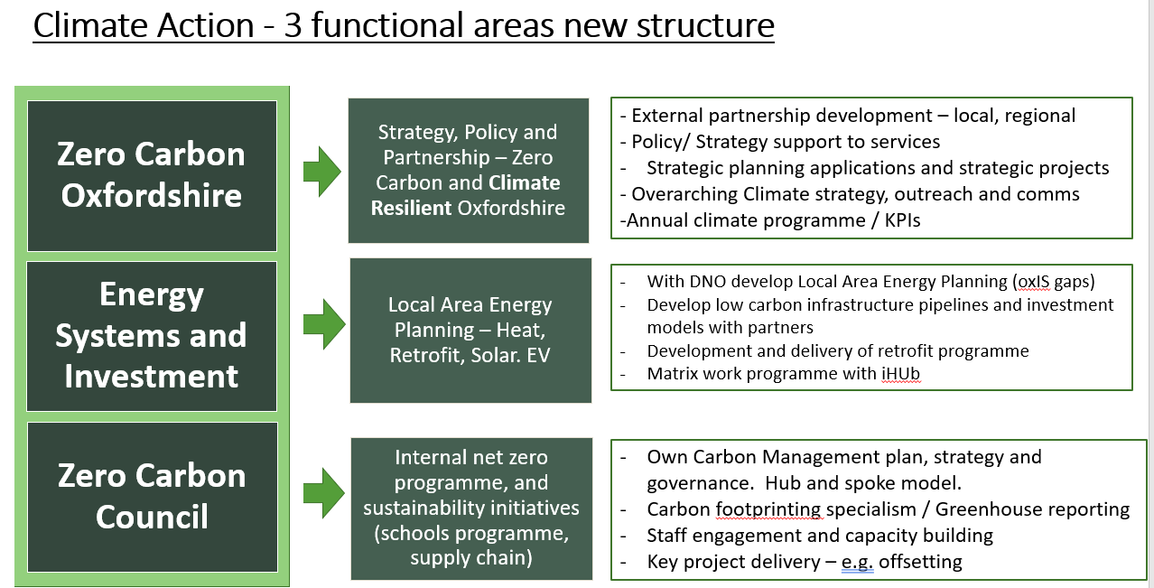

Updated June 2024

